**1.Data su dva broja: a, b. Izračunati sve aritmetičke operacije i prikazati dobijene vrednosti!**

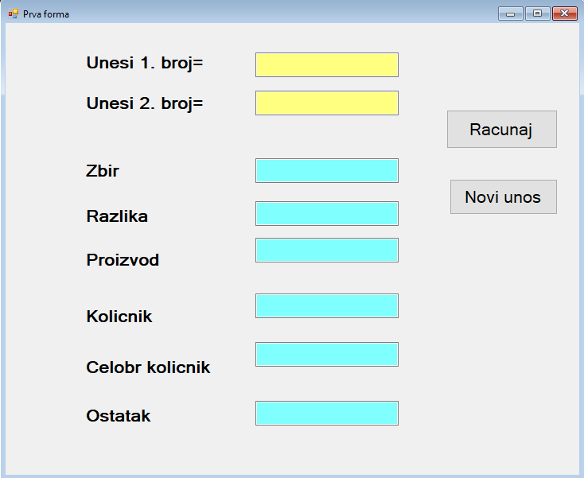

private void btnRacunaj_Click(object sender, EventArgs e)

{

int a = int.Parse(txtA.Text);

int b = int.Parse(txtB.Text);

int z = a + b;

txtZbir.Text = z.ToString();

int r = a - b;

int p = a * b;

double k = a / (double)b;

int ck = a /b;

int ost = a % b;

txtRaz.Text = r.ToString();

txtProiz.Text = p.ToString(); // moze se pisati : Convert.ToString(p)

txtKol.Text = k.ToString("0.00");

txtCk.Text = ck.ToString();

txtOst.Text = ost.ToString();

}

private void btnNoviU_Click(object sender, EventArgs e)

{

txtA.Clear();

txtB.Clear();

txtZbir.Clear();

txtRaz.Clear();

txtProiz.Clear();

txtKol.Clear();

txtCk.Clear();

txtOst.Clear();

txtA.Focus();

}

}

}